Traffic Simulator – Assessment 2 Alwin George (13327981)

Problem specification
We have been tasked with creating a traffic simulator. This simulation is to consist of a top down view of a small city traffic. This simulation must include roads, vehicles and traffic lights and the traffic must follow standard Australian road laws. It needs to display vehicles including cars, busses and motorbikes. The program will be used to simulate traffic and learn about traffic patterns and movement. This problem is designed to help progress our understanding in code simulation. This project could be applied to test and simulate real life scenarios.

UML Class diagram
Inheritance: is a mechanism in which one class acquires the property of another class. For example, a child inherits the traits of his/her parents. With inheritance, we can reuse the fields and methods of the existing class. Hence, inheritance facilitates Reusability and is an important concept of OOPs.
Symbol :

Composition: enables you to reuse code by modelling a has-a association between objects. If you combine the concept of composition with the encapsulation concept, you can exclude the reused classes from your API.
Symbol :

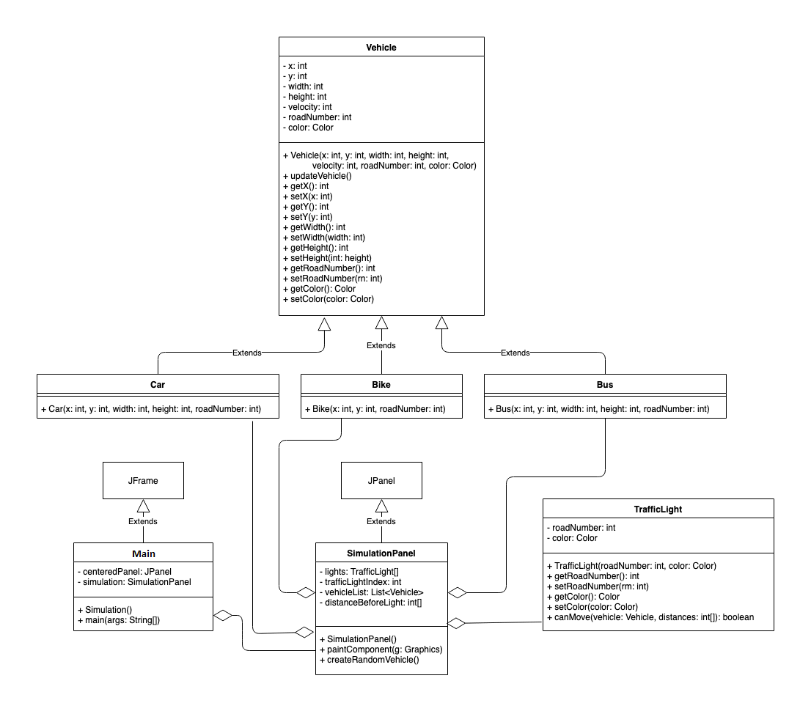

Once the problem was definied and analysed the following the classes were created:
- Bus
- Bike
- Car
- Vehicle
- TrafficlIght
- Main
- SimulationPanel

Vehicle:
This is the model class to represents a vehicle on the road in simulation, it contains the x and y axis position attributes, width and height attributes to represents the size of the vehicle, velocity attributes to show the speed of vehicle on the road, road number to shows that the vehicle is moving on which road of the map, color attributes to show the color of the vehicle which we have to spawn on the road.
Roads are numbers in a clock wise as top to bottom moving road is numbered 1, right to left road is numbered 2, bottom to top road is numbered 3 and left to right moving road is numbered 4.
It contains the getter and setter methods of all attributes in vehicle, it also contains a method to update the vehicle position in every cycle.

Car:
This is the model class which represents a Car on the road in simulation it extends the Vehicle class to get all functionalities of Vehicle class. The color of car is Green and width of car is 10 pixels and height is 5 pixels.

Bus:
This is the model class which represents a Bus on the road in simulation it extends the Vehicle class to get all functionalities of Vehicle class. The color of Bus is Blue and width of bus is 30 pixels and height is 5 pixels.

Bike:
This is the model class which represents a Bike on the road in simulation it extends the Vehicle class to get all functionalities of Vehicle class. The color of bike is red and width of bike is 5 pixels and height is 5 pixels.

TrafficLight:
This is the model class which represents a Traffic Light on the road in simulation. It contains the attributes including road number which shows that this traffic light is placed on which road number and control the traffic flow of which road, it also contains the current color of the traffic light, as Red color represents to stop vehicles and green color represents to continue the traffic. It also contains the getter and setter methods of all attributes. This class contains the most important method of the whole program which named as canMove, it takes the vehicle and distance from traffic light to vehicle, the main feature of this method to tell the car in each cycle that is it allowed to move on the road or not taking traffic light color in mind. It calculates the distance of each vehicle from traffic light and stop it so that no any car overlaps with other car and stop at least a 10 pixel safe distance from other class. But if the traffic light is green it allows all the cars to move on road until it became red again.

Main:
This class extends the JFrame class to create the GUI. There is a main method in this class which starts the execution of the program. JFrame contains the SimulationPanel class which is used to show the graphics.

SimulationPanel:
This class extends the JPanel class to fetch the feature to draw graphics on the screen. The total size of this panel is 500 pixels in width and 500 pixels in height. There are 2 roads drawn with gray color on map with a white single line to separate 2 lanes of the roads, and it also draw 4 traffic lights to control the flow of the traffic on the road.
An array of TrafficLight class with the size of 4 elements is used to keep track of the traffic light color and the process of making the 1 light as green and other lights as red iteratively, a trafficLightIndex integer variable which keep track of the green light, after specific interval it makes the current traffic light as red and increase it by 1 and make the next traffic light as green to allow traffic movement, 4th attribute is the list of Vehicle class to keep track of all vehicles moving on the road so that we can stop and change their position according to the conditions, fifth attribute is the array of distance between lights with a length of 4, as we have 4 lights, it represents the current distance from traffic light on which vehicles have to stop and the distance is change by time as many cars stop on the traffic light in a lane, basically it used to keep a safe distance from other cars so that no any car crashes.
First the traffic lights intialse and the distance from lights arrays. And then it starts 3 threads to run the program in flow without any error or issues. 1st thread is to iteratively change traffic lights. It runs in a while loop, thread sleeps for 5 seconds than change the current green traffic light to red and wait for another 500 milliseconds so that the car which just passes the traffic light can easily cross the road before cars from other roads starting movement, than it increase the index of traffic light and make the next traffic light as green to continue the flow. After this complete execution it calls the “repaint” method of the JPanel class to remove all drawn data and redraw all the objects on the screen with new updated attributes. Next thread is used to make a flow of the vehicles on the road, it also have a while loop running in it, in a loop, it stops for 10 milliseconds than iterate through all the vehicles in the list and update the location of the vehicle on the road and call “repaint” method to redraw everything. Thrid thread is used to create a random vehicle which would be bike, car or bus and it spawn randomly or different road with different starting and ending points after every 1 second. In paintComponent method, it first creates the road, than traffic lights, and then run a for loop to draw all of the vehicles on the screen by using their methods of finding their locations. All these methods works simultaneously to make the flow of the traffic without any accident and any issue.

